

GROUP ASSIGNMENT

TECHNOLOGY PARK MALAYSIA

CT127-3-2-PFDA

PROGRAMMING FOR DATA ANALYSIS

HAND OUT DATE: 27 MARCH 2026

HAND IN DATE: 29 MAY 2026

WEIGHTAGE: 50%

INSTRUCTIONS TO CANDIDATES:

- Students are advised to underpin their answers with the use of references (cited using the American Psychological Association (APA) Referencing).
- Late submission will be awarded zero (0) unless Extenuating Circumstances (EC) are upheld.
- Cases of plagiarism will be penalized.
- Submit the assignment to APU Learning Management System.
- You must obtain 50% overall to pass this module.

Group No: 5
Ian Chin Jun Sheng TP076218
Isac Lim Yong Hao TP076305
Lai Ker Jinn TP077827
Soh Ye Wen TP078275

Version 3.1 EC 2019 -Oct

Table of Contents
1.0 Introduction 3
1.1 Data Description (kj) 4
1.2 Assumption (isac) 4
1.3 Hypothesis and Objectives 5
1.3.1 Hypothesis 6
1.3.2 Objective 1: To examine whether employee salary has any impact on attrition by analysing the salaries of employees grouped according to their attrition level. (TP076218) 6
1.3.2 Objective 2: To investigate the relationship between job satisfaction, performance rating and employee attrition. Isac Lim Yong Hao (TP07305) 6
1.3.3 Objective 3: To analyse and determine the effect of job satisfaction on employee attrition Lai Ker Jinn (TP077827) 6
1.3.4 Objective 4: To analyse and determine the relationship between work-life balance and employee attrition Soh Ye Wen (TP078275) 7
2.0 Data Preparation (ian/yw) 7
2.1 Data Import 8
2.1.1 Load Libraries 8
2.1.2 Load the Dataset 8
2.2 Cleaning / pre-processing 9
2.2.1 Clean Column: Attrition 9
2.2.2 Clean Column: BusinessTravel 9
2.2.3 Clean Column: Department 10
2.2.4 Clean Column: EducationField 11
2.2.5 Clean Column: Gender 11
2.2.6 Clean Column: JobRole 11
2.2.7 Clean Column: MaritalStatus 12
2.2.8 Clean Column: OverTime 13
2.2.9 Clean Numeric Columns 13
2.2.10 Handle Remaining Missing Values 14
2.2.11 Remove Irrelevant Columns 15
2.2.12 Save Cleaned Dataset 16
2.3 Data Validation 16
2.3.1 Set Working Directory & Import Data 17
2.3.2 Check for Duplicates (Cleaning & Data Validation) 17
2.3.3 Unique Values Inspection 18
2.3.4 Verify Clean Data 18
2.2.5 Final Missing Value Check 19
3.0 Objective 1: (Ian Chin Jun Sheng TP076218) 20
3.1 Descriptive Analysis 20
4.0 Objective 2: (Isac Lim Yong Hao TP076305) 20
4.1 Descriptive Analysis 20
4.1.1 Job Satisfaction and Attrition 20
4.1.2 Performance Rating and Attrition 21
4.2 Predictive Analysis 22
4.2.1 Logistic Regression 22
4.2.2 Decision Tree 22
4.3 Model Comparison 23
5.0 Objective 3: (Lai Ker Jinn TP077827) 25
6.0 Objective 4: (Soh Ye Wen TP078275) 25
6.1 Descriptive Analysis 25

Table of Figure
Figure 1: Dataset Description 5
Figure 2: Load Libraries 9
Figure 3: Load the Dataset 10
Figure 4: Clean Column: Attrition 10
Figure 5: Clean Column: BusinessTravel 11
Figure 6: Clean Column: Department 11
Figure 7: Clean Column: EducationField 12
Figure 8: Clean Column: Gender 12
Figure 9: Clean Column: JobRole 13
Figure 10: Clean Column MaritalStatus 13
Figure 11: Clean Column: OverTime 14
Figure 12: Clean Numeric Columns 15
Figure 13: Handle Remaining Missing Values 16
Figure 14: Remove Irrelevant Columns 17
Figure 15: Save Cleaned Dataset 17
Figure 16: Check for Missing Values 18
Figure 17: Check for Duplicates 18
Figure 18: Unique Values Inspection 19
Figure 19: Verify Clean Data 20
Figure 20: Final Missing Value Check 20
Figure 21: Bar Chart 27
Figure 22: Box Plot 28
Figure 23: Summary Statistics 29
Figure 24: Logistic Regression 30
Figure 25: Stacked Bar Chart 31

1.0 Introduction

1.1 Data Description (kj)
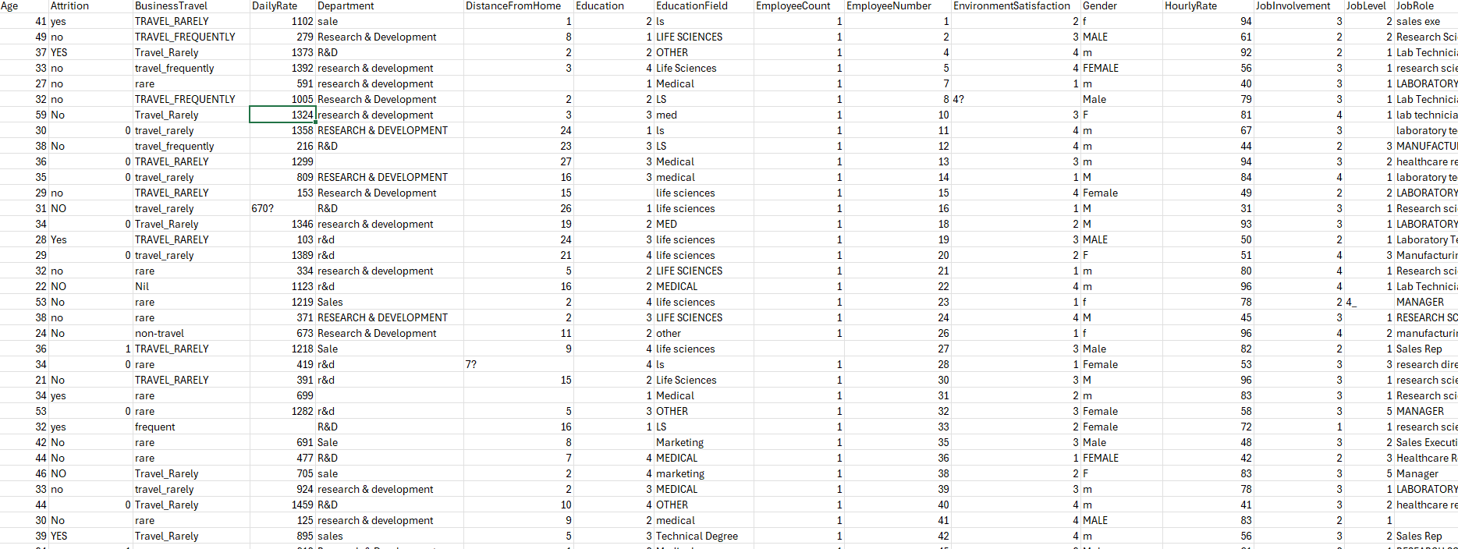
Figure 1: Dataset Description

This dataset includes comprehensive information about employees within an organization, it focuses on demographic details, job-related attributes, compensation, performance and satisfaction levels. It mainly used to analyse the impact on affecting employee attrition and overall workforce behaviour.

1.2 Assumption (isac)
There are no duplicate entries in the dataset, so each record is assumed to be a unique employee. It is also assumed that each employee makes their own decision about leaving and that the decisions of other employees in the same organization don't have a direct effect on that decision.

1.3 Hypothesis and Objectives

1.3.1 Hypothesis
Lower salary for most of the employee will leads to employee attrition

1.3.2 Objective 1: To examine whether employee salary has any impact on attrition by analysing the salaries of employees grouped according to their attrition level. Ian Chin Jun Sheng (TP076218)
Descriptive analysis:
- Boxplot and summary statistics comparing MonthlyIncome between Attrition = Yes and Attrition = No groups.
- Income bracket bar charts (Low / Mid / High / Unknown) showing employee count and attrition rate (%) per bracket.
Predictive analysis:
- K-Nearest Neighbors (KNN) classifier to predict attrition based on MonthlyIncome, evaluated using a confusion matrix.

1.3.2 Objective 2: To investigate the relationship between job satisfaction, performance rating and employee attrition. Isac Lim Yong Hao (TP07305)
Descriptive analysis:
Using bar charts, boxplots, and summary statistics to look at and show the differences in job satisfaction and performance ratings between employees who left and those who stayed. By looking at the data across different satisfaction and rating categories, this helps find patterns and trends in how job satisfaction and performance affect employee turnover.
Predictive analysis:
Apply a logistic regression model with factors like job satisfaction rating and performance rating as predictors to guess how likely it is that an employee will leave. Then, look at how these factors can affect the likelihood of employee attrition. A Decision Tree model will also be used to figure out if an employee will stay or leave based on how happy and productive they are.

1.3.3 Objective 3: To analyse the effect of overtime on employee attrition

Lai Ker Jinn (TP077827)
Descriptive Analysis:
Bar charts, boxplots, and summary statistics will be used to examine the relationship between career progression and employee attrition. Variables such as Years at Company, Years in Current Role and Years Since Last Promotion will be compared between employees who left and those who stay.
By visualizing these variables, patterns and trends can be identified, such as whether employees with fewer promotion opportunities or longer stagnation in the same role will leave more. Boxplots will help show the distribution and spread of these variables across attrition groups, while bar charts will highlight differences in frequency. This analysis will help determine whether limited career growth is associated with higher employee turnover.

Predictive Analysis:
Logistic Regression would be used to compute the probability of employee turnover considering the career progress variables, including Years Since Last Promotion, Years in Current Job, and Years at Company.
Furthermore, a Decision Tree approach would be implemented to classify employees by career progress variables, thereby making it easier to interpret decision-making rules, such as employees who have been working in the same company for long without getting promoted having a greater likelihood of leaving the company. Additionally, the Random Forest approach would be utilized to enhance prediction accuracy and evaluate the contribution of career progress variables in predicting employee turnover.

1.3.4 Objective 4: To analyse and determine the relationship between work-life balance and employee attrition Soh Ye Wen (TP078275)
Descriptive Analysis:
The bar charts, boxplots, and summary statistics (mean and median) will be used to conduct descriptive analysis to look at the distribution of work-life balance levels between employees who left and employees who remained. As work life balance is a scale of 1 (Bad) to 4 (Best), these methods can be used to visualize patterns, trends and differences in central tendency between the two groups. This can be used to determine whether there is a relationship between poor work-life balance and increased employee turnover.
Predictive Analysis:
The models to be used in predictive analysis will include Logistic Regression, Decision Tree and Random Forest. The probability of the employees to be attracted or not will be estimated using logistic Regression to find the probability of leaving the company based on work-life balance. The Decision Tree model will be able to reflect non-linear relationships and give understandable rules of classification that will be used to predict the possibility of an employee leaving or staying. Also, the Random Forest model will be applied to enhance the accuracy of the predictions and the significance of the work-life balance as a predictor of the employee attrition.

2.0 Data Preparation

2.1 Data Import

2.1.1 Load Libraries
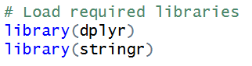
Figure 2: Load Libraries
Function:
- library() - loads external packages
Explanation:
- dplyr - used for data manipulation (e.g., select())
- stringr - helps with string/text processing (though you mainly used base functions like gsub, grepl)

2.1.2 Load the Dataset
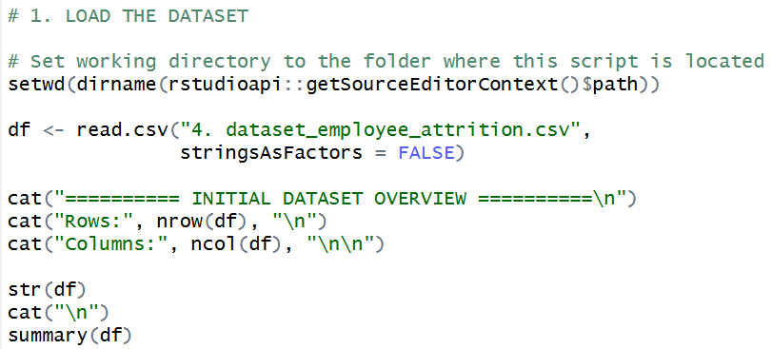
Figure 3: Load the Dataset
Explanation:
In this step, setwd( ) along with dirname( ) and rstudioapi: getSourceEditorContext() is applied to change the working directory to the position of the script. read.csv() is used to import the dataset. The cat() is used with the functions nrow() and ncol() to show the number of rows and columns. Lastly, the structure and statistical summary of the data is analyzed using str and summary.

2.2 Cleaning / pre-processing

2.2.1 Clean Column: Attrition
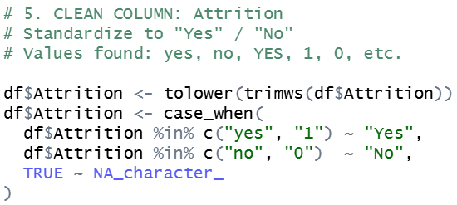
Figure 4: Clean Column: Attrition

Explanation:
Standardization of text is done by the functions tolower() and trimws() which change text to lower case and eliminate spaces. Next, case when and in percent are applied to convert the values of "yes" and "1" to "Yes" and "no" and "0" to "No". Any unmatched values are fixed to NA, which makes it uniform.

2.2.2 Clean Column: BusinessTravel
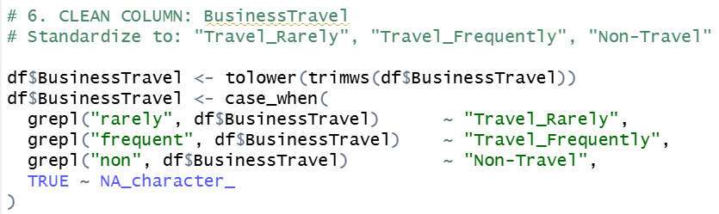
Figure 5: Clean Column: BusinessTravel

Explanation:
The functions tolower() and trimws() standardize the text format. Then, grepl() is used for pattern matching to detect keywords like "rarely" and "frequent". These patterns are processed using case_when() to assign standardized categories such as "Travel_Rarely" and "Travel_Frequently".

2.2.3 Clean Column: Department
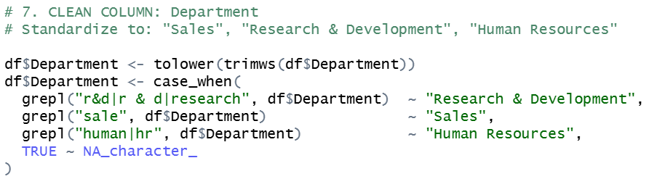
Figure 6: Clean Column: Department

Explanation:
Functions like lowercase() and trimws() are used to clean the text format and grepl() is used to find keywords such as, "research", "sale" and "Hr". These are then subclassified into regular categories with case_when().

2.2.4 Clean Column: EducationField
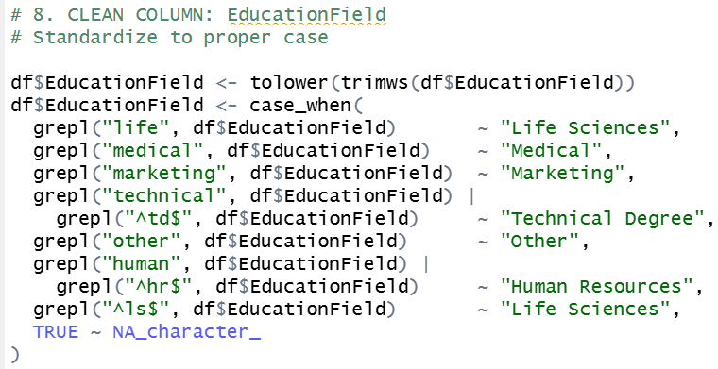
Figure 7: Clean Column: EducationField
Explanation:
The tolower() and trimws() standardize the text and grepl() finds patterns like "life", "medical", "technical". Case_when() is then used to map these to standardized categories to be consistent.

2.2.5 Clean Column: Gender
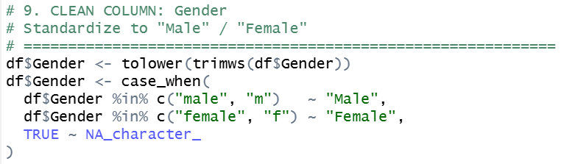
Figure 8: Clean Column: Gender
Explanation:
Tolower() and trimws() standardize text, and the standardizing of abbreviations such as "m" and "f" to "Male" and "Female" respectively in case_when() is facilitated using the standardizing percent operator, in this case, percent.

2.2.6 Clean Column: JobRole
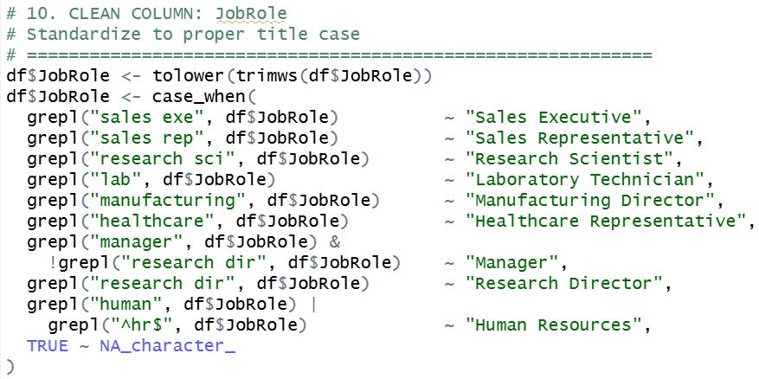
Figure 9: Clean Column: JobRole
Explanation:
lower() and trimws() are used to purify the text format and grepl() is used to find patterns like "sales exe" or "manager". These are standardized into the same job titles by case_when().

2.2.7 Clean Column: MaritalStatus
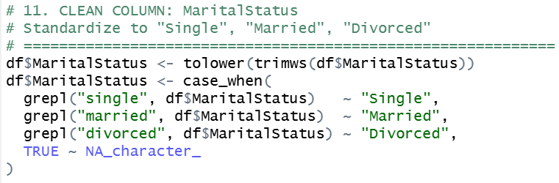
Figure 10: Clean Column MaritalStatus
Explanation:
The text is readyized with tolower() and trimws() functions, and the categories such as "single", "married", and "divorced" are identified with the grepl() function. Case_when() is used to standardize them.

2.2.8 Clean Column: OverTime
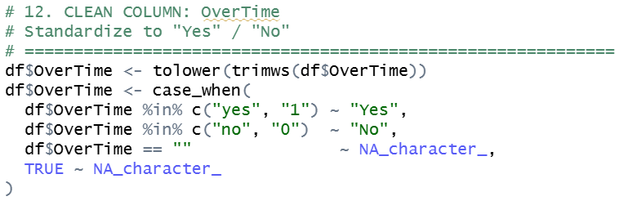
Figure 11: Clean Column: OverTime
Explanation:
The text is standardized with the functions tolower() and trimws() and the case_when() converts the text "yes"/"1" and "no"/"0" to "Yes" and "No" respectively. Missing values (NA) are empty strings.

2.2.9 Clean Numeric Columns
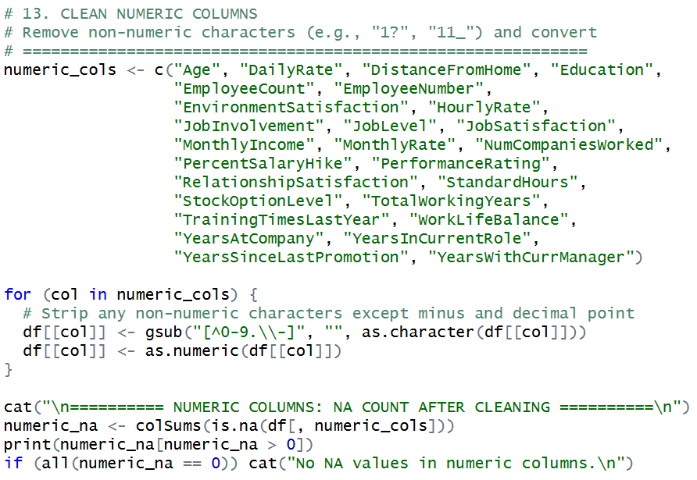
Figure 12: Clean Numeric Columns
Explanation:
The gsub() function is applied to eliminate undesired characters of numeric values. Then, the proper format is made sure with as.character() and then the cleaned values are converted to numeric with as.numeric().

2.2.10 Handle Remaining Missing Values
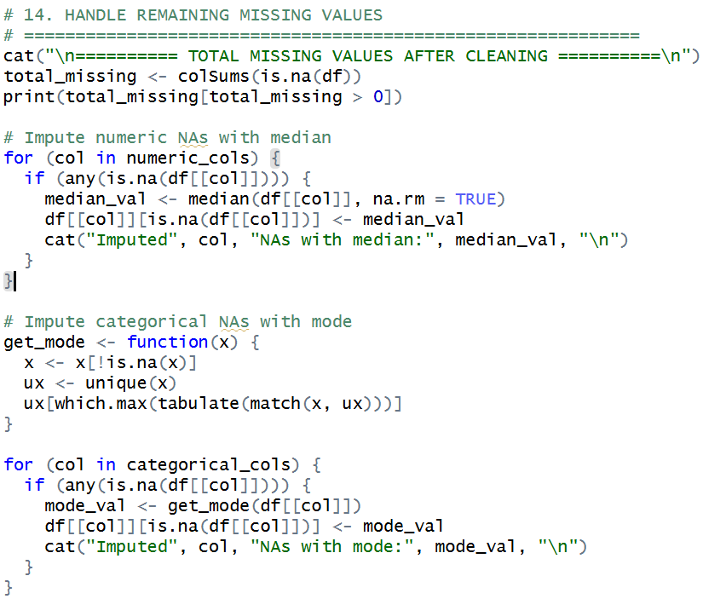
Figure 13: Handle Remaining Missing Values
This step is done by using is.na() and colSums() to find out the remaining missing value and print only the affected column out by using print, and cat to format the outcome.
This is done with a for loop with any(is.na) and a median to replace missing values with the median to maintain resistance to outliers.
In case of categorical data, an individual function is developed with the help of function(), unique(), match(), tabulate() and which.max() functions, to identify the mode (most repeated value). This mode is substituting the lack of categorical values in another for loop.
This step, overall, takes care of all the missing values in an adequate way, making the data complete and coherent.

2.2.11 Remove Irrelevant Columns
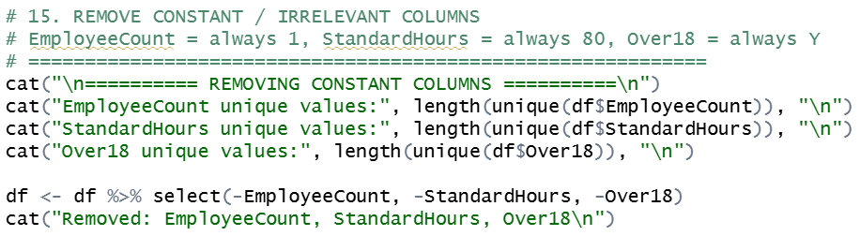
Figure 14: Remove Irrelevant Columns
Explanation:
The unique() operation is used to determine the presence of a single value in columns and the select() operation complied with the pipe operator is used to eliminate the irrelevant columns that do not add any valuable information.

2.2.12 Save Cleaned Dataset
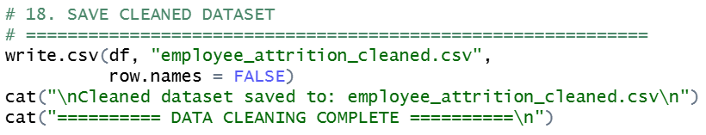
Figure 15: Save Cleaned Dataset
Explanation:
The cleaned data is then exported to a new CSV file through the function write.csv() which makes it available to be further analysed.

2.3 Data Validation

2.3.1 Set Working Directory & Import Data
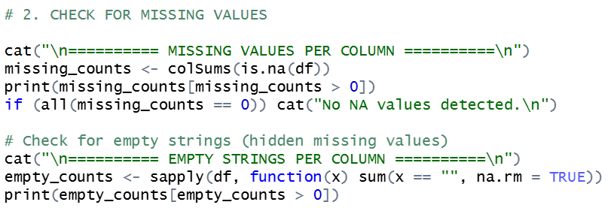
Figure 16: Check for Missing Values
Explanation:
Missing values can be identified with the function.na() and the number of missing values in a column was counted by using colSums. To ensure that even concealed missing values are found, sapply() is also used together with sum() to detect empty strings in each column (i. e. "").

2.3.2 Check for Duplicates (Cleaning & Data Validation)
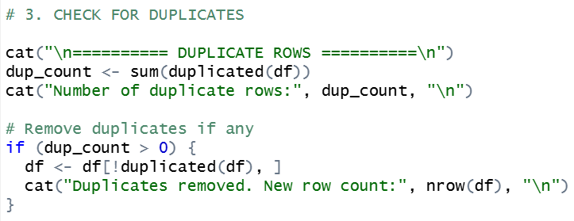
Figure 17: Check for Duplicates

Explanation:
The duplicated() function is applied to find the duplicated rows, and sum is the number of duplicated rows. The presence of the duplicates is checked using an if condition and by logical indexing [ ] and the operation of !duplicated() to delete these duplicate rows in the dataset.

2.3.3 Unique Values Inspection
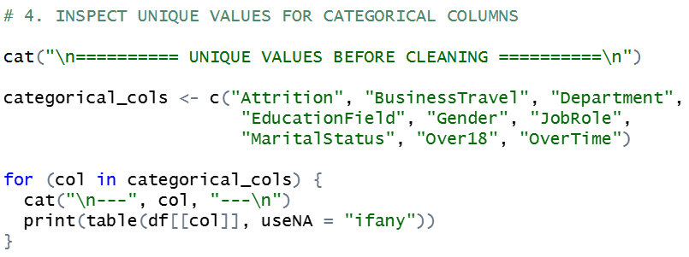
Figure 18: Unique Values Inspection

Explanation:
The for loop is to loop through categorical columns and table (applied to each column accessed via the [[ ]]) is applied to each column to show the frequency of unique values. This helps identify inconsistencies in categorical data.

2.3.4 Verify Clean Data
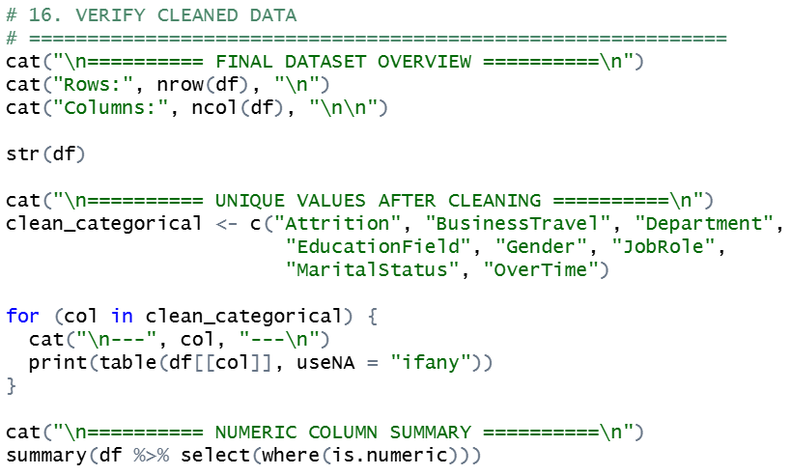
Figure 19: Verify Clean Data
Explanation:
Checking of the structure and statistical summary of the cleaned data is done through the functions str() and summary(), and the distribution of categorical values is done through checking table.

2.2.5 Final Missing Value Check
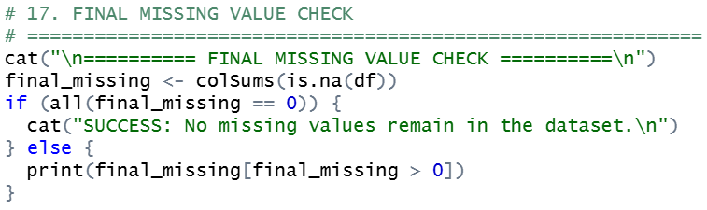
Figure 20: Final Missing Value Check
Explanation:
It is repeated with the functions of is.na() and colSums() to ensure that all missing values have been effectively managed.

3.0 Objective 1: (Ian Chin Jun Sheng TP076218)

3.1 Descriptive Analysis

3.1.1 Analysis 1-1: Distribution of Monthly Income by Attrition Group
Analysis Technique:
A summary statistics table and boxplot are used to examine and compare the distribution of MonthlyIncome between employees who left (Attrition = Yes) and those who remained (Attrition = No). The group_by() and summarise() functions from the dplyr package compute descriptive statistics including count, mean, median, standard deviation, minimum, and maximum monthly income for each attrition group. The boxplot is constructed using ggplot2, where the box represents the interquartile range (IQR), the horizontal line marks the median, a diamond symbol indicates the mean, and red dots represent outliers. Together, these provide a comprehensive overview of income distribution and central tendency across both groups.
[Insert screenshot of R source code and output here]
Findings:
The summary statistics and boxplot reveal a notable difference in MonthlyIncome between the two attrition groups. Employees who remained (Attrition = No) recorded a higher median monthly income of USD 5,171 and a mean of USD 6,843.50 across 1,665 employees, while employees who left (Attrition = Yes) had a lower median of USD 3,904 and a mean of USD 5,288.30 across 305 employees. The interquartile range of the “No” group is wider, reflecting greater income diversity among retained employees. Although high-income outliers are present in both groups, a greater concentration of lower incomes is observed among those who left. This consistent difference in central tendency suggests that employees earning a lower monthly income are more likely to leave the organisation, supporting the hypothesis that salary is a key contributing factor to employee attrition.

3.1.2 Analysis 1-2: Attrition Rate by Monthly Income Bracket
Analysis Technique:
Employees are grouped into three monthly income brackets — Low (below USD 3,000), Mid (USD 3,000 to USD 9,000), and High (above USD 9,000) — with a fourth “Unknown” category assigned to the 29 employees whose MonthlyIncome values are missing. Rather than deleting these records or treating them as NA, missing values are encoded as a separate meaningful category, which preserves all 2,000 records in the analysis. The case_when() function is used for bracket assignment and factor() locks the display order. Two charts are generated using ggplot2: a grouped bar chart showing the absolute count of employees who stayed and left within each bracket, and a stacked percentage bar chart displaying the attrition rate (%) per bracket, which enables fair comparison across brackets of unequal size.
[Insert screenshot of R source code and output here]
Findings:
The income bracket analysis reveals a clear inverse relationship between monthly income and attrition rate. Employees in the Low bracket (below USD 3,000) experienced the highest attrition rate at 25.6%, with 126 out of 493 employees leaving the organisation. In the Mid bracket (USD 3,000–9,000), the attrition rate dropped significantly to 12.9% (131 out of 1,013 employees), while the High bracket (above USD 9,000) recorded the lowest attrition rate at 10.5% (49 out of 465 employees). Employees with unknown income records had a 6.9% attrition rate (2 out of 29), which may reflect data gaps associated with senior or confidential-pay roles rather than a genuine low-risk profile. Overall, the Low income bracket shows more than double the attrition rate of the High bracket, consistently reinforcing that lower-paid employees face a substantially higher risk of leaving and that MonthlyIncome is a critical driver of employee attrition.

4.0 Objective 2: (Isac Lim Yong Hao TP076305)

4.1 Descriptive Analysis

4.1.1 Job Satisfaction and Attrition
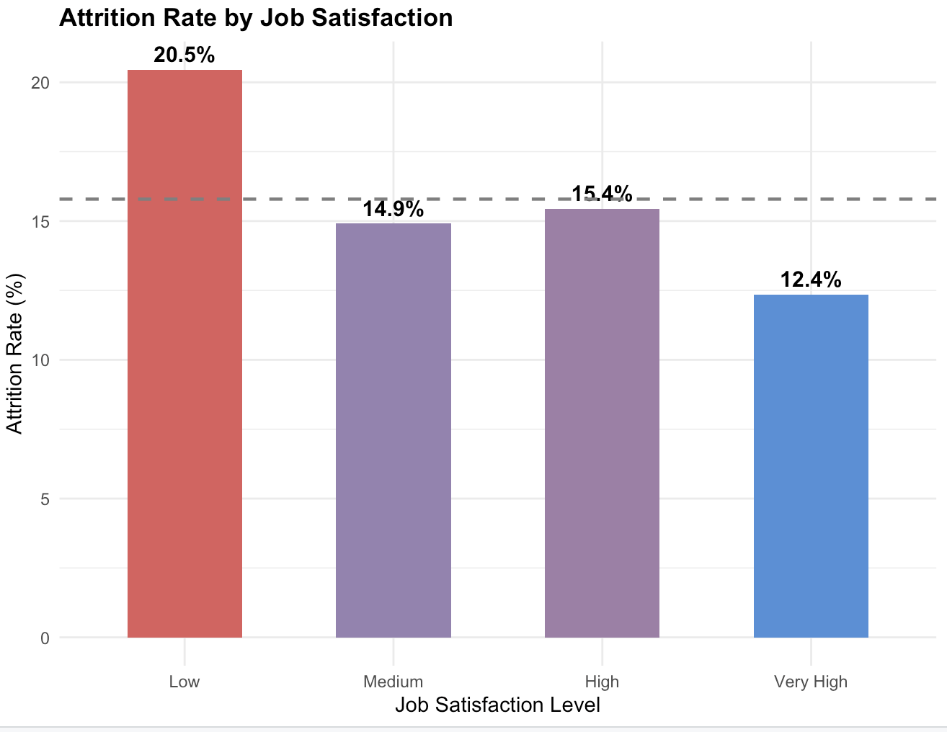

The charts demonstrate a definite negative correlation between attrition and work satisfaction. Employee turnover was highest among those with poor satisfaction and lowest among those with very high satisfaction. Additionally, summary figures show that the average satisfaction of departing employees was lower than that of remaining employees.
This pattern is supported by the boxplot and stacked bar chart, which reveal lower median satisfaction and a higher percentage of "Low" and "Medium" contentment among those who departed. In general, one of the main factors affecting employee attrition is job satisfaction.

4.1.2 Performance Rating and Attrition
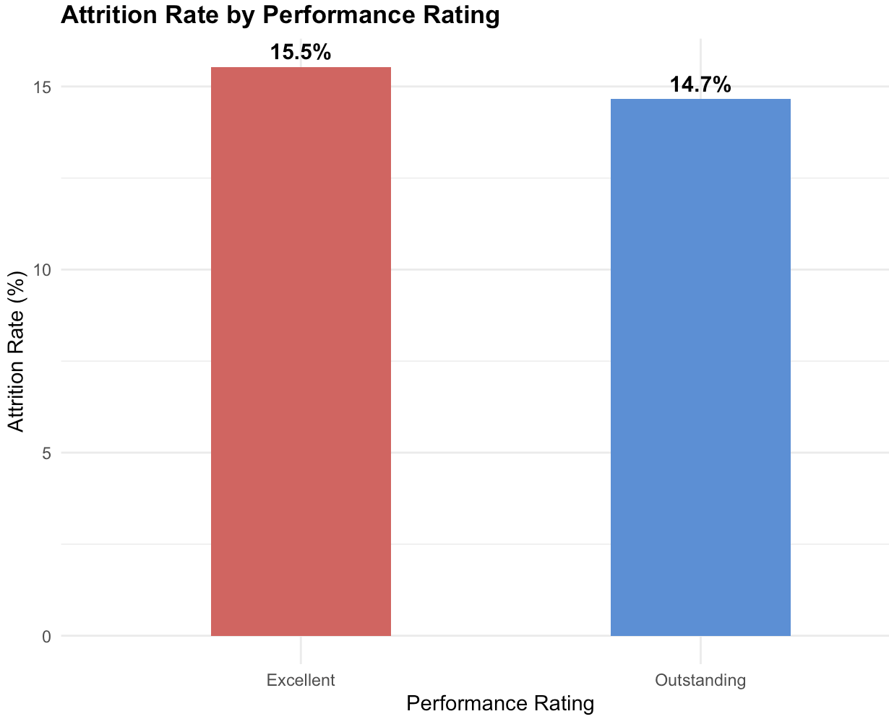
The correlation between performance rating and attrition was weaker than that of job satisfaction. There were only a slight difference and no discernible directional trend in the bar graph comparing attrition rates between personnel rated "Excellent" (Rating 3) and "Outstanding" (Rating 4). The mean performance rating was almost the same for both attrition groups, according to the summary statistics, indicating that performance rating by itself is not a reliable indicator of employee turnover. This result suggests that high-performing workers are not always more likely to stick around, which could reflect organizational problems like insufficient recognition or few prospects for career growth.

4.2 Predictive Analysis
4.2.1 Logistic Regression
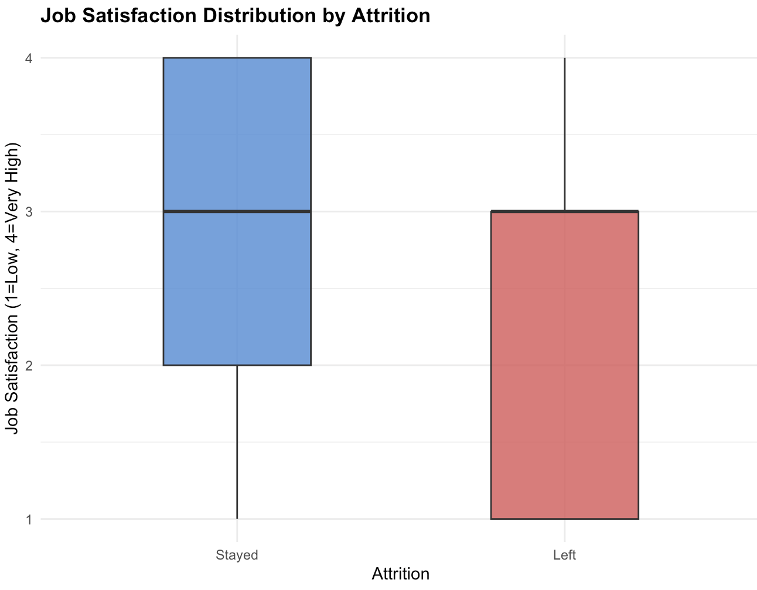
Performance ratings and work satisfaction were used to predict employee attrition in a binary logistic regression model. Higher job satisfaction levels are linked to a lower likelihood of leaving, according to the model coefficients, which showed that job satisfaction exhibited a negative impact on the log-odds of retention (coefficient = −0.2119). In contrast, the performance rating coefficient was close to zero (−0.0091), indicating that it showed little predictive power in this two-variable model. The model's overall accuracy was about 84%, although this number is mostly due to the model's propensity to accurately classify the majority class (staying employees) while missing most real attrition cases. The model's discriminatory strength is only slightly enhanced by the Area Under the ROC Curve (AUC) of roughly 0.57.

4.2.2 Decision Tree

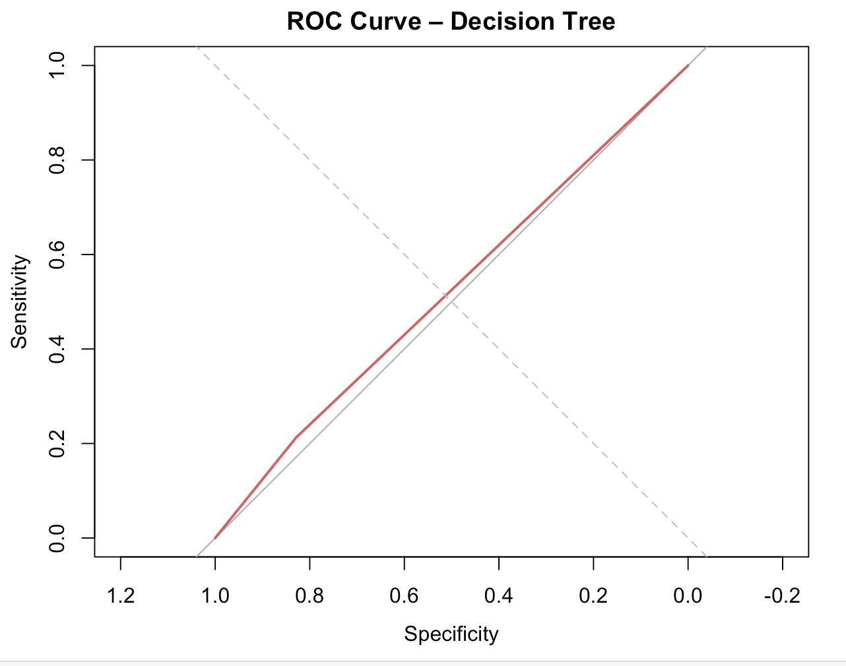
To address the class disparity between departing and remaining employees, a Decision Tree classifier with a maximum depth of three was trained on the same set of predictors using balanced class priors. The resultant feature important ratings confirmed that job happiness is the primary factor in differentiating among the two attrition outcomes, attributing roughly 81% of the predictive weight to work satisfaction and 19% to performance rating. Although the Decision Tree outperformed the logistic regression model in terms of sensitivity in identifying employees who were at danger of leaving, its total accuracy was lower, which illustrates the trade-off involved in accounting for class imbalance. Similar restricted discriminatory performance is suggested by the AUC of roughly 0.52.

4.3 Model Comparison
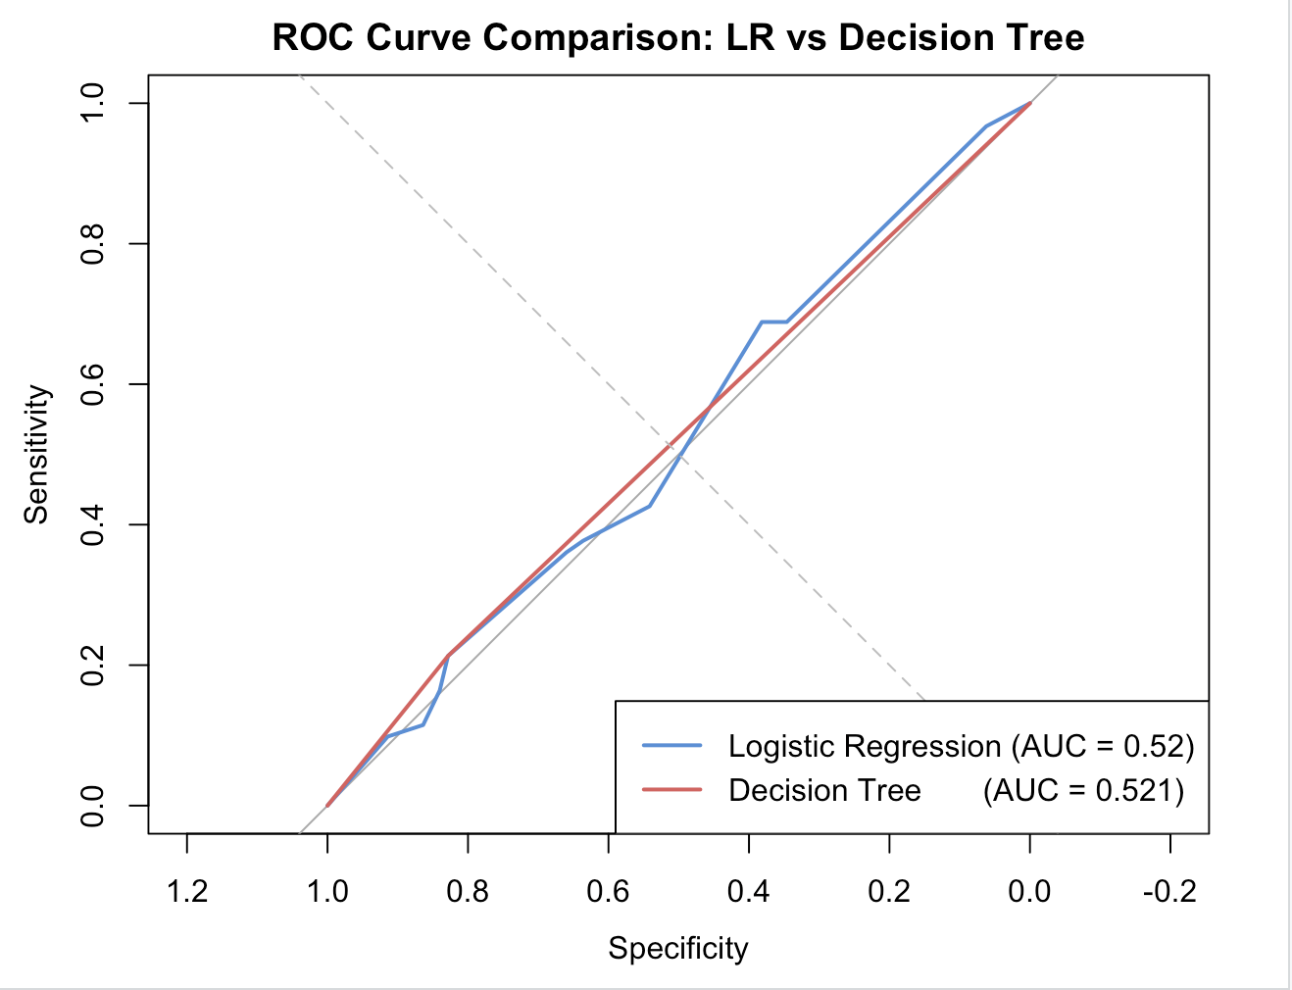
Both models performed slightly better than the baseline random classifier, but neither achieved a significantly higher AUC, according to the ROC curve overlay comparison between the Decision Tree and Logistic Regression models. In comparison to the Decision Tree (≈ 0.52), the Logistic Regression model achieved a little higher AUC (≈ 0.57), indicating marginally better overall discrimination. But because of its explicit decision criteria and node-level probability outputs, the Decision Tree provided more interpretability, which might be more helpful in applied HR scenarios where prediction logic openness is valued. Given that there were only two predictor variables, it is not surprising that neither model showed significant predictive performance overall.
4.4 Conclusion and Findings
Considering the relationship between work satisfaction, performance rating, and employee attrition, the analysis of Objective 2 produced several significant conclusions. First, both descriptive and predictive analyses consistently found that work satisfaction was the main factor linked to attrition, with lower levels of satisfaction being related with higher turnover rates. Second, performance rating showed a little correlation with attrition, suggesting that staff productivity is not a reliable indicator of retention on its own. Third, the low predictive accuracy of both models, as evidenced by AUC values near 0.5, shows that, although important, job satisfaction and performance rating are insufficient to accurately forecast attrition on their own. Future investigations ought to involve other factors including years at the company, monthly pay, and overtime status, which are probably enhance model performance and offer a more thorough comprehension of the elements influencing employee attrition.

5.0 Objective 3: (Lai Ker Jinn TP077827)

6.0 Objective 4: (Soh Ye Wen TP078275)

6.1 Descriptive Analysis

6.1.1 Bar Chart
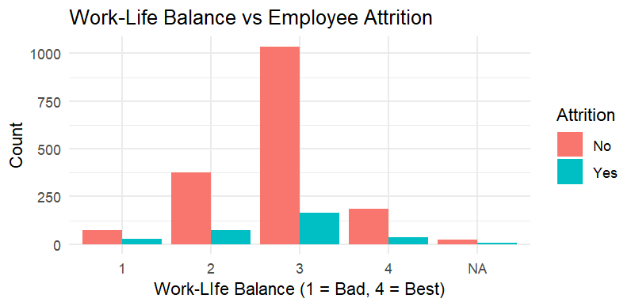
Figure 21: Bar Chart
The bar chart shows the correlation between the level of work- life balance and the rate of attrition of employees by comparing the number of employees who remained and left the company on a scale of 1 (Bad) to 4 (Best). The distribution shows that most employees have a work-life balance level of 3, which implies that the perception of the work-life balance is rather moderate in the organization. Even though non-attrition cases prevail in all the categories, a comparatively increased percentage of attrition is evident among employees who have lower levels of work-life balance (levels 1 and 2). Conversely, the levels of work-life balance (3 and 4) relate to lower percentage of employees who are going to leave the organization. This trend indicates that there is a negative correlation between work-life balance and attrition, with a better work-life balance potentially leading to higher employee retention. These results suggest initial evidence of inclusion of work-life balance as an important predictor in later predictive modelling methodologies including the logistic regression and decision tree analysis.

6.1.2 Box Plot
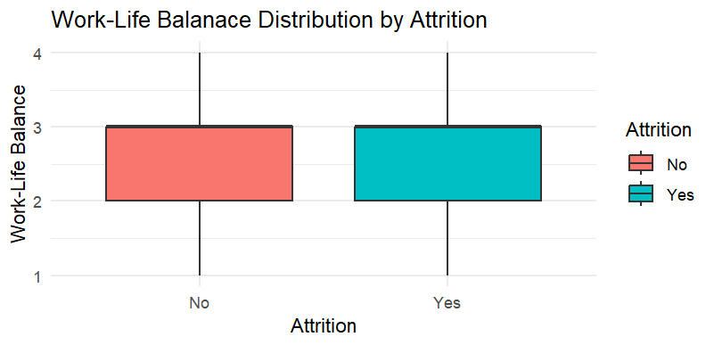
Figure 22: Box Plot
The boxplot shows how the scores of work-life balances are distributed among employees who remained working in the organization (No), and those who left (Yes). The median of both groups is close to level 3, which means that the average perception of work-life balance is moderate irrespective of the attrition status. Nonetheless, the distribution of the information indicates a minor difference as both groups have a spectrum of lower (1–2) to higher (3–4) levels of work-life balance. The overlapping interquartile ranges suggest that work-life balance might not have a strong distinguishing effect between those who leave and those who remain. However, the departed employees seem to be somewhat more variable in terms of lower work-life balance levels, indicating that in some instances poor work-life balance might be the cause of attrition. Altogether, the difference is not very significant, yet the distribution confirms the assumption that work-life balance affects employee turnover to some extent and should be analysed with the help of predictive modelling methods further.

6.1.3 Summary Statistics (mean, median, distribution)
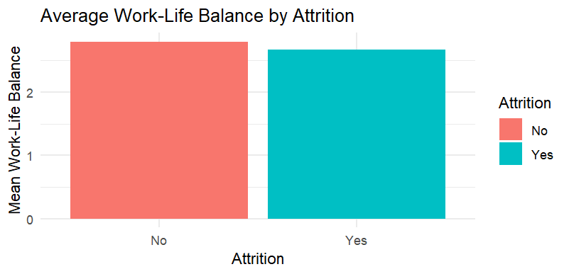
Figure 23: Summary Statistics
The summary statistics were calculated using the data grouped according to the status of attrition and determining the mean and median work-life balance of each group. The above statistics were also represented in a bar chart to easily compare the stay and leave employees (No and Yes respectively). The findings indicate that those workers who stayed in the organization have a marginally better work-life balance on average than those who left. Though this difference is not much, it implies that a higher work-life balance can help reduce employee turnover. The similarity in values further shows that work-life balance as a determinant might not be very powerful, but it nevertheless depicts a discernible pattern where a low work-life balance is linked to a high possibility of dropping out of the organization. These results corroborate previous visualizations and provide the rationale to use the predictive modelling method to analyse the relationship further.

6.2 Predictive Analysis

6.2.1 Logistic Regression
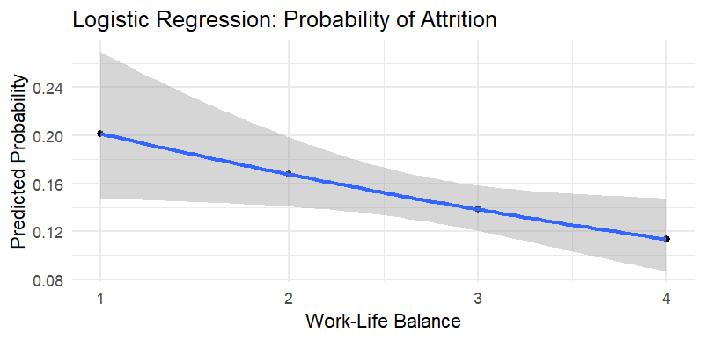
Figure 24: Logistic Regression
The logistic regression model was developed to estimate the likelihood of the employee leaving a company depending on the Work-Life Balance scores. The X-axis is the Work-Life Balance score (between 1-low and 4-high) whereas the Y-axis is the projected probability of attrition. The grey shaded zone around the blue line is the 95% confidence interval which shows the range of uncertainty of the predictions.
The results show that employees with a score of 1 on Work-Life Balance are most likely to be affected by attrition with the highest probability of about 20% and those with a score of 4 are least likely to be affected with the lowest probability of about 12%. This declining pattern supports the fact that in the better the work-life balance, the lower the chances of an employee leaving the organization. Although this 8-percentage point difference is not very high, it still represents a discernible trend in which low work-life balance is, time and again, associated with a high likelihood of attrition.
The confidence interval is broadened at each extreme of the scale especially in scores 1 and 4, indicating that the model is less confident in its predictions at these points as there are fewer employees in these categories. The fact that the probabilities predicted in the middle scores are more similar also indicates that work-life balance as a univariate predictor might not be strong enough on its own. However, these findings support the earlier visualizations and give an analytical foundation to establish that work-life balance is significantly and negatively related to employee attrition.

6.2.2 Stacked Bar Chart
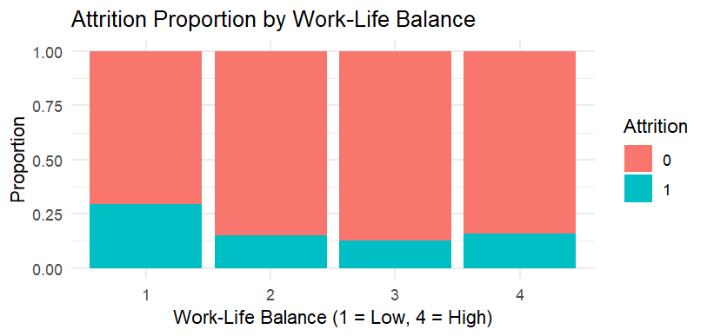
Figure 25: Stacked Bar Chart
The stacked bar chart was built based on the data that was combined based on the Work-Life Balance scores and the percentage of attrition status at the level. The bar shows the percentage of employees who quit (1) and those who did not (0) in four Work-Life Balance scores of 1 (low) to 4 (high). The results show that workers with a score of 1 on the Work-Life Balance are the ones with the highest rate of attrition at around 30% which is significantly greater than that of scores 2, 3 and 4 that are all around 15. This implies that workers who have a low work-life balance have very high chances of leaving the organization.
Although there is a rather insignificant gap between the scores 2, 3, and 4, the trend nonetheless shows a certain tendency according to which low work-life balance correlates with the increased risk of attrition. The fact that the proportions are similar between the higher scores also demonstrates that work-life balance as a predictor might not be a very effective predictor as there are other determinants that can make an employee decide to leave a job even when work-life balance is good. Such findings support earlier visualizations and cement the argument of applying predictive modelling to further examine the correlation between the work-life balance and employee turnover.

